EXECUTIVE SUMMARY: AUTOMATED TECHNICIAN TASK MATCHING SYSTEM

Sue Byeon
MSDS 498 Capstone
December 2, 2025

Project Overview
The telecommunications industry powers modern connectivity, yet many providers struggle to deliver consistent field service quality. Technician assignments are often made manually or through basic rule-based methods that prioritize availability or proximity over skill alignment. Consequently, 42% of tasks are mismatched, leading to a 42% failure rate, $16.8K in total penalty costs, and declining customer satisfaction. These inefficiencies limit scalability, reduce margins, and weaken both technician morale and customer trust.
To address these challenges, this project introduces an Automated Technician Task Matching System that uses data analytics and machine learning to assign tasks based on technician expertise, task requirements, and historical performance. This shift from reactive scheduling to predictive, data-driven assignments aims to reduce task failures, lower operational costs, and enhance customer satisfaction through more accurate and efficient technician-task matching.
Data Description
Two datasets sourced from Kaggle were transformed into three relational tables—Technicians, Historical Tasks, and Unassigned Tasks—as shown in Figure 1. The original datasets contained records of field service assignments, task outcomes, and technician details, where each record represented a unique service task with attributes describing operational logistics, task requirements, and technician suitability. The final transformed schema consolidates technician information, historical performance, and upcoming service requests to establish relationships linking technicians to both completed and pending assignments, enabling performance tracking and predictive task allocation. To ensure consistency across datasets, Penalty Cost and Customer Rating were recalculated in the Historical Tasks table using formulas defined in the Unassigned Tasks dataset. Additionally, the Technicians table was enhanced by deriving Equipment Trained and Technical Complexity attributes from Expertise Match data, representing each technician’s capability to handle tasks of varying complexity and equipment requirements.
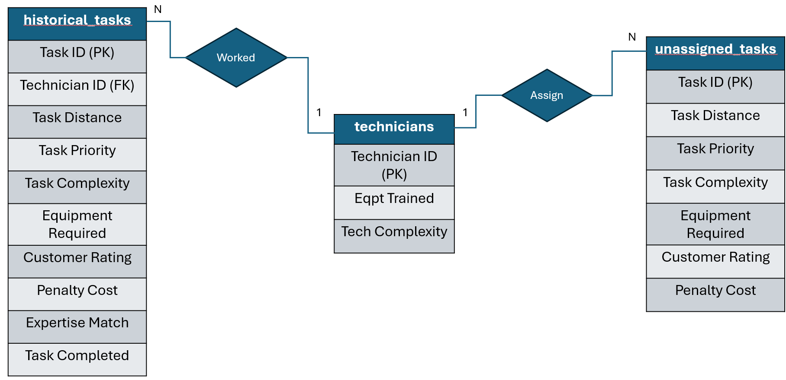
Figure 1: Entity Relationship Diagram
Methodology & Deliverable
This project predicts the probability of successful task completion for each technician using key features such as task distance, priority, complexity, required equipment, technician expertise, customer ratings, and penalty costs. A binary classification model was developed using XGBoost in Python to identify the technician most likely to complete a given task successfully. To promote fairness and reduce bias toward frequently assigned technicians, a SoftMax-based selection mechanism was applied, converting predicted probabilities into weighted random choices. The final model achieved 83.3% accuracy and a ROC-AUC of 0.667, demonstrating reliable predictive performance.
The model is fully integrated into a web-based management application designed for field service supervisors to automate and oversee task delegation, as shown in Figure 2. The homepage features an “Assign Task” button that triggers the model via an API call, automatically selecting the most suitable technician for the chosen task. The application also includes views for technician profiles, historical task records, and incoming unassigned tasks (Figures 3 and 4). The backend, built with Python’s FastAPI, supports automated and manual task management, while the frontend, developed with React, delivers a responsive and intuitive interface for real-time, model-driven decision-making.
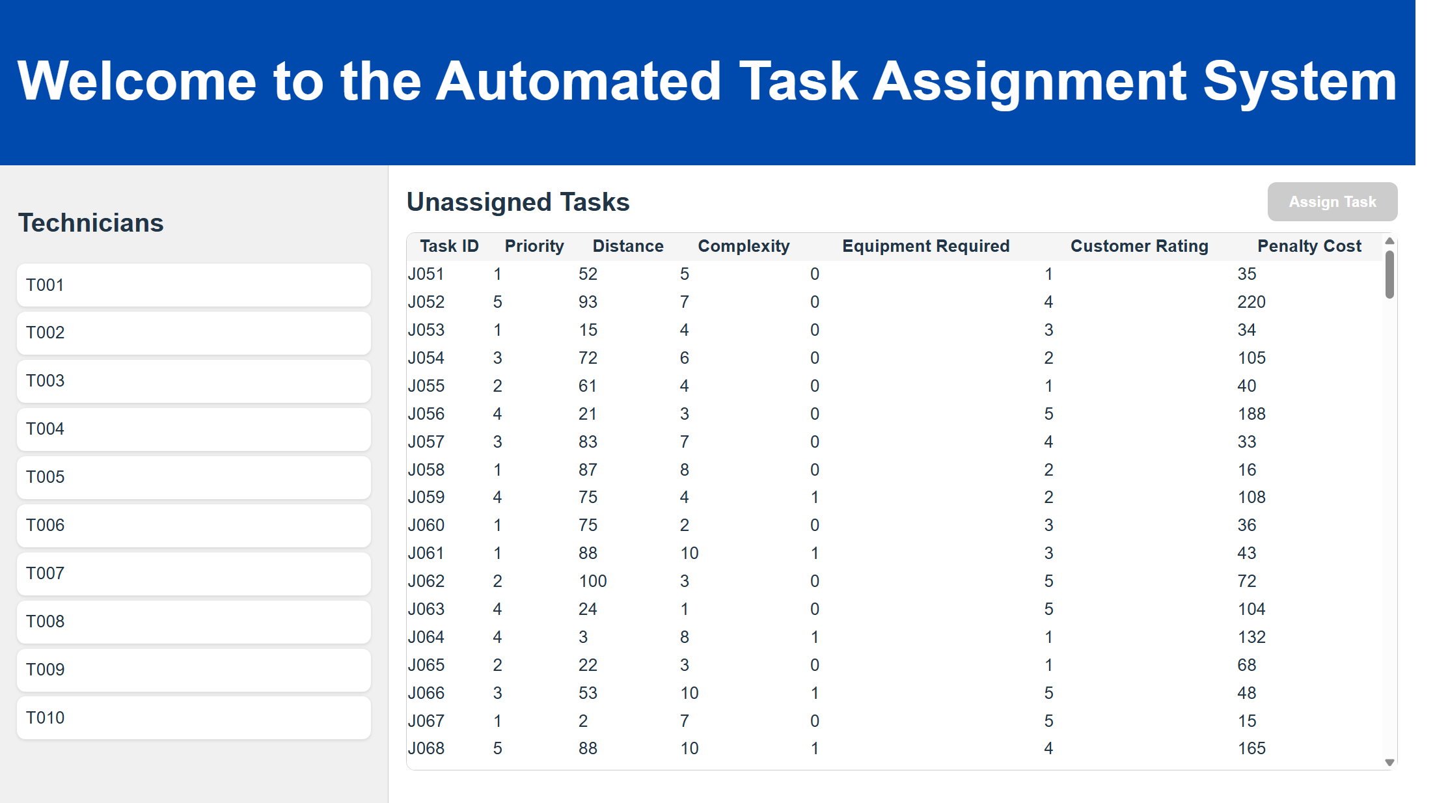
Figure 2: Home Page
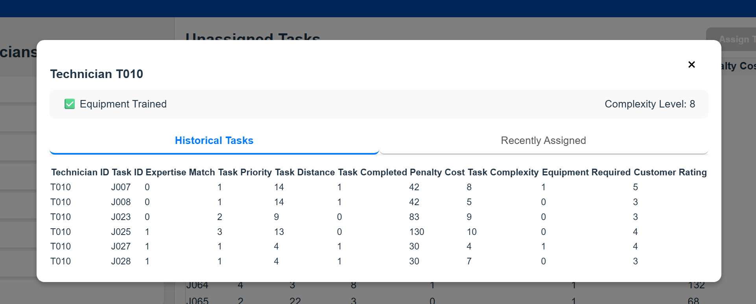
Figure 3: Technician's Historical Tasks View
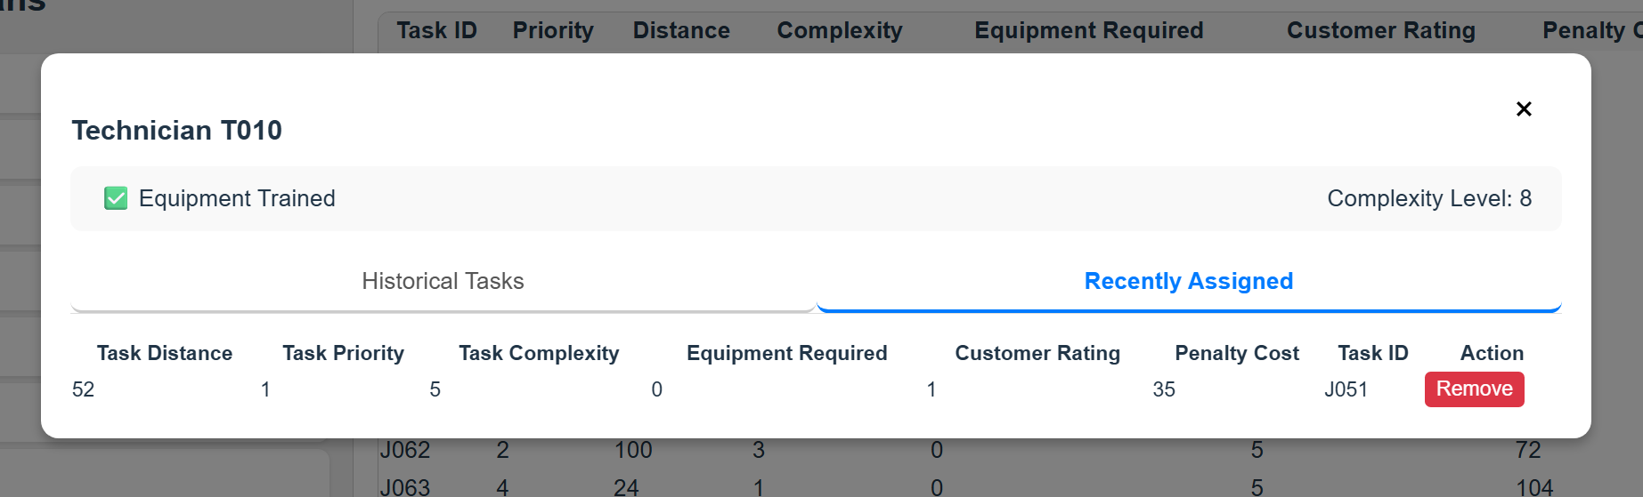
Figure 4: Technician's Assigned Task View
Results & Benefits
After full implementation and simulation, the automated technician task-matching system delivered substantial improvements across financial, operational, and reputational dimensions.
Financial Impact:
The most immediate benefit was a marked reduction in penalty costs, which dropped from $16.8K to $4.1K—a savings of over 75%. As shown in Figure 5, the majority of these savings resulted from more successful completion of urgent or high-priority tasks, particularly those that were less complex and routine. This demonstrates the system’s ability to prioritize and resolve tasks that carry the highest financial risks for the business.
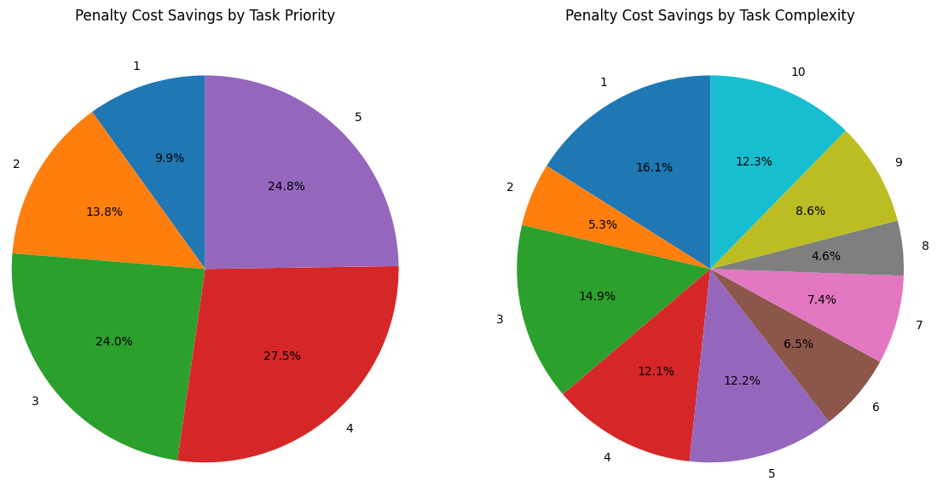
Figure 5: Breakdown of Penalty Cost Savings by Task Priority and Task Complexity
Operational Impact:
Operational efficiency also saw a significant boost. The overall task completion rate improved by 32%, rising from 58% to 76.5%, which directly reflects the effectiveness of the automated assignment process. While the overall expertise match rate remained steady at 58%, deeper analysis (see Figures 6 and 7) reveals that when expertise was matched, technicians were more likely to complete tasks successfully post-implementation. The system also made it clearer that tasks lacking proper expertise match were less likely to be completed, indicating more precise and meaningful task assignments. These improvements translate into faster job turnaround, reduced error rates, and more efficient utilization of field resources.
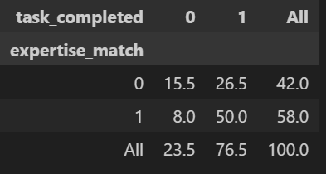
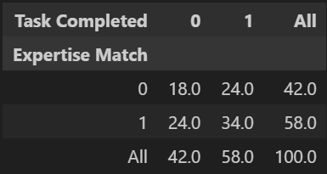

Figure 7: Post-Implementation Cross Table
Figure 6: Pre-Implementation Cross Table
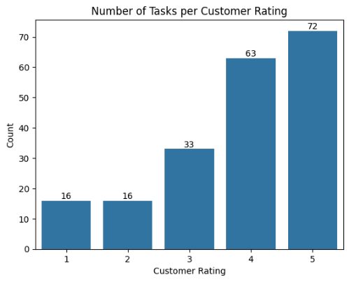
Reputational Impact:
Customer satisfaction, as measured by customer rating scores, improved markedly. The average rating increased by 20%, reaching 3.66. Figure 8 illustrates a left-skewed distribution, indicating a positive shift in customer perceptions and validating that the system delivers a better experience. Higher customer ratings enhance the company’s reputation, foster loyalty, and can serve as a competitive differentiator in the telecommunications market.
Figure 8: Customer Rating Bar Graph
Limitations & Future Work
The primary limitation of this project lies in the small training dataset, which restricts the model’s ability to learn diverse patterns and increases the risk of overfitting. Additionally, the lack of contextual data across both datasets limited the accuracy of engineered features such as technician complexity and equipment training, reducing overall model depth and generalizability.
Future improvements include expanding data collection from live service and technician platforms to strengthen model performance and reliability. Integrating a real-time data pipeline and route optimization would further enhance scheduling efficiency by accounting for travel times, geographic constraints, and dynamic conditions such as sudden outages, demand spikes, or technician unavailability.
Conclusion
The Automated Technician Task Matching System demonstrates a practical and scalable solution for improving field service efficiency in the telecommunications industry. By leveraging data-driven decision-making, it enhances task accuracy, reduces operational costs, and supports more consistent customer experience. Successful implementation will require thoughtful change management and technician training programs to ensure smooth adoption and alignment with existing workflows. With proper integration and stakeholder engagement, this system can set a new standard for intelligent, industry-aligned field service operations.
Appendix A: Formal Literature Search
A.1. Introduction
This appendix reviews recent advances in technician scheduling and task-matching systems. The objective is to identify current approaches, key findings, and how this project’s method differentiates itself by focusing on technician-level predictive matching.
A.2. Review of Existing Work
Field Technician Scheduling with Experience-Dependent Service Times (MDPI, 2023): Utilizes mixed-integer programming to optimize schedules based on technician experience and historical service times, achieving reduced average service durations.
Technician Routing and Scheduling for Tasks with Uncertain Resolution Locations (DTU, 2023): Proposes robust optimization for generating new routing scenarios, addressing uncertainty in task locations and aiming to minimize idle and travel time. which is great for companies that want to completely overhaul their systems.
Enhanced Iterated Local Search for the Technician Routing and Scheduling Problem (arXiv, 2023): Applies advanced local search algorithms to technician routing, demonstrating improved schedule efficiency relative to basic heuristics.
A.3. Differentiation and Contribution
In contrast to Technician Routing and Scheduling for Tasks with Uncertain Resolution Locations (DTU, 2023), my project focuses on optimizing what organizations already have—ideal for companies that need incremental improvements and can’t afford to hire more technicians or make major structural changes.
Field Technician Scheduling with Experience-Dependent Service Times (MDPI, 2023) and Enhanced Iterated Local Search for the Technician Routing and Scheduling Problem (arXiv, 2023) introduce advanced optimization algorithms like Iterated Local Search to find the best overall routing and scheduling for technicians. Their main goal is to maximize company efficiency by redesigning full schedules. My approach is different: instead of optimizing the entire schedule, I predict how likely each technician is to successfully complete individual tasks. This allows more flexible and personalized task assignments based on each technician’s history.
While prior work focuses on optimizing entire schedules or creating new systems, this project leverages predictive modeling focusing more on aligning tasks with the technician’s strengths. This is essentially making their jobs easier and setting them up for success while the other approaches primarily optimize for company outcomes. This technician-centered perspective can indirectly improve overall operational efficiency by boosting task completion rates which would also appeal to the company's goal for cost savings and increasing customer satisfaction.

References
The Field Technician Scheduling Problem with Experience-Dependent Service Times (MDPI, 2023)
Technician Routing and Scheduling for Tasks with Uncertain Resolution Locations (Technical University of Denmark, 2023)
Enhanced Iterated Local Search for the Technician Routing and Scheduling Problem (arXiv, 2023)

